

Activity based
Project Report on
Artificial Intelligence
C2P2 Project Module - II
Submitted to Vishwakarma University, Pune
Under the Initiative of

Contemporary Curriculum, Pedagogy, and Practice (C2P2)

By
Mangesh Tate
SRN No: 202201868
Roll No: 38
Div: E
Third Year Engineering
Subject Teacher: Richa Agnihotri
Department of Computer Engineering Faculty of Science and Technology

Academic Year
2024-2025


Artificial

Intelligence:

Project

2
Project Name:

-
Best First Search algorithm to find optimal paths for robot
-
navigation

1)Problem Statement
Implement the Best-First Search algorithm, incorporating heuristic functions to guide the search towards promising paths while considering obstacle avoidance and robot dynamics. Develop a user-friendly interface for users to input environment maps, robot parameters, and target locations, and visualize generated path plans, enhancing user experience and facilitating efficient path planning

2)Project Objectives and Implementation Plan:
The objective of this project is to develop a path planning system using the Best-First Search algorithm for efficient robot navigation in indoor environments. The system aims to explore the search space intelligently by using heuristic functions to guide the robot toward the target while avoiding obstacles. A graphical user interface (GUI) is implemented to allow users to dynamically create and visualize maps, define robot start and goal positions, and observe the computed path in real-time.
Implementation Plan:
1)Requirement Analysis and Dataset Collection:
Grid-based space, obstacle density, dynamic/static map. Choose input methods: manual obstacle placement or random generation.
2)Map Generation and Preprocessing:
Mark navigable cells and obstacles, Allow user to input start and goal positions via GUI. Preprocess grid to ensure valid inputs and accessible goals.
3)Heuristic Design:
The heuristic prioritizes cells that are estimated to be closer to the goal.
4)Best-First Search Algorithm Integration:
Implement Best-First Search using a priority queue (heapq) based on heuristic values.
5)Pathfinding Visualization and Output:
Highlight the searched path in light blue, and final path in yellow. Show start (green), goal (red), and obstacles (black) with the total number of steps in the path.
6)Deployment and User Interface:
Buttons for setting start, goal, obstacles, and triggering search, Allow dynamic input and reset for multiple test cases.

3)Methodology
1.Identify Dataset
Dataset Type- Occupancy of Grid Maps. The grid size will be entered by the user.
Input Parameters-Grid dimensions (e.g., 5x5, 10x10),Start position (row, col),Goal position (row, col)
2.Preprocess dataset
Validation of User Input-Ensure grid values are only 0 or 1,check if start and goal positions are valid (within bounds and not on obstacles).
Convert input into Python-compatible data structures-2D list for grid, tuples for start and goal positions
3.Implement algorithm
Use Best-First Search with a priority queue (min-heap). Track visited nodes and parent pointers to reconstruct the final path. Handle edge cases-No path exists, Start is the goal, Obstacle at start or goal
4.Implementation of GUI
Grid display with-
S for start
G for goal
yellow for path
black for obstacles
5. Verify output with expected output based on domain knowledge
Compare generated path with manually verified path-Ensure shortest path is selected based on heuristic, Output should avoid obstacles.
6.Validation and testing
Test on different grids-Open grid (no obstacles), Complex grid with multiple obstacles,Edge case: No possible path

4.Source Code:
import tkinter as tk
from tkinter import messagebox, simpledialog
import heapq
import time
import random

# ------------------------------
# AI COMPONENT 1: Heuristic Function
# ------------------------------
# The Manhattan Distance heuristic helps the search algorithm decide
# which cell is *most promising* to explore next.
# This is a core concept of AI (Informed Search).
def heuristic(a, b):
return abs(a[0] - b[0]) + abs(a[1] - b[1])

# ------------------------------
# AI COMPONENT 2: Best-First Search Algorithm
# ------------------------------
# This is an AI search algorithm used in Robotics, Navigation, and Game AI.
# It uses the heuristic to intelligently choose the next best move.
def best_first_search(grid, start, goal, canvas, rects, cell_size, animate=False):

# Priority Queue → explores BEST cell first (AI decision-making)
pq = []
heapq.heappush(pq, (heuristic(start, goal), start))

visited = set()
parent = {start: None}

while pq:
_, current = heapq.heappop(pq)

# Goal Reached → AI achieved optimal navigation
if current == goal:
return reconstruct_path(goal, parent)

visited.add(current)

# Visualization of AI search progress
if animate:
r, c = current
if current != start and current != goal:
canvas.itemconfig(rects[r][c], fill="lightblue")
canvas.update()
time.sleep(0.05)

# Explore neighboring cells (Up, Down, Left, Right)
for dr, dc in [(-1, 0), (1, 0), (0, -1), (0, 1)]:

nr, nc = current[0] + dr, current[1] + dc
neighbor = (nr, nc)

# Skip invalid or blocked cells
if (0 <= nr < len(grid) and 0 <= nc < len(grid[0]) and
grid[nr][nc] != 1 and
neighbor not in visited and
neighbor not in parent):

# AI uses heuristic to prioritize neighbors closer to goal
heapq.heappush(pq, (heuristic(neighbor, goal), neighbor))

# Track movement for path reconstruction
parent[neighbor] = current

return None

# ------------------------------
# AI COMPONENT 3: Path Reconstruction
# ------------------------------
# Once the goal is found, AI reconstructs the final optimal path.
def reconstruct_path(goal, parent):
path = []
current = goal
while current is not None:
path.append(current)
current = parent[current]
return path[::-1]

# ------------------------------
# GUI (User Interface)
# ------------------------------
class PathPlanningApp:
def __init__(self, root):
self.root = root
self.root.title("Robot Path Planning - Best First Search")

self.cell_size = 40
self.rows = simpledialog.askinteger("Input", "Enter number of rows:", minvalue=5, maxvalue=30)
self.cols = simpledialog.askinteger("Input", "Enter number of columns:", minvalue=5, maxvalue=30)

self.canvas = tk.Canvas(root, width=self.cols * self.cell_size, height=self.rows * self.cell_size)
self.canvas.pack()

self.grid = [[0 for _ in range(self.cols)] for _ in range(self.rows)]
self.rects = [[None for _ in range(self.cols)] for _ in range(self.rows)]

self.start = None
self.goal = None

self.canvas.bind("<Button-1>", self.on_click)
self.mode = "obstacle"

self.build_buttons()
self.draw_grid()
self.place_initial_obstacles(count=30)

def build_buttons(self):
frame = tk.Frame(self.root)
frame.pack()

tk.Button(frame, text="Set Start", command=self.set_start_mode).pack(side=tk.LEFT)
tk.Button(frame, text="Set Goal", command=self.set_goal_mode).pack(side=tk.LEFT)
tk.Button(frame, text="Set Obstacle", command=self.set_obstacle_mode).pack(side=tk.LEFT)
tk.Button(frame, text="Run Search", command=self.run_search).pack(side=tk.LEFT)
tk.Button(frame, text="Reset", command=self.reset).pack(side=tk.LEFT)

def draw_grid(self):
for r in range(self.rows):
for c in range(self.cols):
x1, y1 = c * self.cell_size, r * self.cell_size
x2, y2 = x1 + self.cell_size, y1 + self.cell_size
rect = self.canvas.create_rectangle(x1, y1, x2, y2, fill="white", outline="gray")
self.rects[r][c] = rect

def place_initial_obstacles(self, count=30):
placed = 0
while placed < count:
r = random.randint(0, self.rows - 1)
c = random.randint(0, self.cols - 1)
if self.grid[r][c] == 0:
self.grid[r][c] = 1
self.canvas.itemconfig(self.rects[r][c], fill="black")
placed += 1

def on_click(self, event):
row = event.y // self.cell_size
col = event.x // self.cell_size

if row >= self.rows or col >= self.cols:
return

if self.mode == "start":
if self.start:
old_r, old_c = self.start
self.canvas.itemconfig(self.rects[old_r][old_c], fill="white")
self.start = (row, col)
self.canvas.itemconfig(self.rects[row][col], fill="green")

elif self.mode == "goal":
if self.goal:
old_r, old_c = self.goal
self.canvas.itemconfig(self.rects[old_r][old_c], fill="white")
self.goal = (row, col)
self.canvas.itemconfig(self.rects[row][col], fill="red")

elif self.mode == "obstacle":
if self.grid[row][col] == 0:
self.grid[row][col] = 1
self.canvas.itemconfig(self.rects[row][col], fill="black")

def set_start_mode(self):
self.mode = "start"

def set_goal_mode(self):
self.mode = "goal"

def set_obstacle_mode(self):
self.mode = "obstacle"

def run_search(self):
if not self.start or not self.goal:
messagebox.showwarning("Warning", "Please set both start and goal.")
return

# Reset obstacle cells visually
for r in range(self.rows):
for c in range(self.cols):
if self.grid[r][c] == 1:
self.canvas.itemconfig(self.rects[r][c], fill="black")

# ------------------------------
# AI CALL: Run Best-First Search
# ------------------------------
path = best_first_search(self.grid, self.start, self.goal, self.canvas, self.rects, self.cell_size, animate=True)

if path:
for (r, c) in path:
if (r, c) != self.start and (r, c) != self.goal:
self.canvas.itemconfig(self.rects[r][c], fill="yellow")
messagebox.showinfo("Path Found", f"Path length: {len(path)} steps.")
else:
messagebox.showinfo("No Path", "No path found to the goal.")

def reset(self):
self.canvas.delete("all")
self.grid = [[0 for _ in range(self.cols)] for _ in range(self.rows)]
self.rects = [[None for _ in range(self.cols)] for _ in range(self.rows)]
self.start = None
self.goal = None
self.draw_grid()
self.place_initial_obstacles(count=30)

# Run the App
if __name__ == "__main__":
root = tk.Tk()
app = PathPlanningApp(root)
root.mainloop()
5.Output:
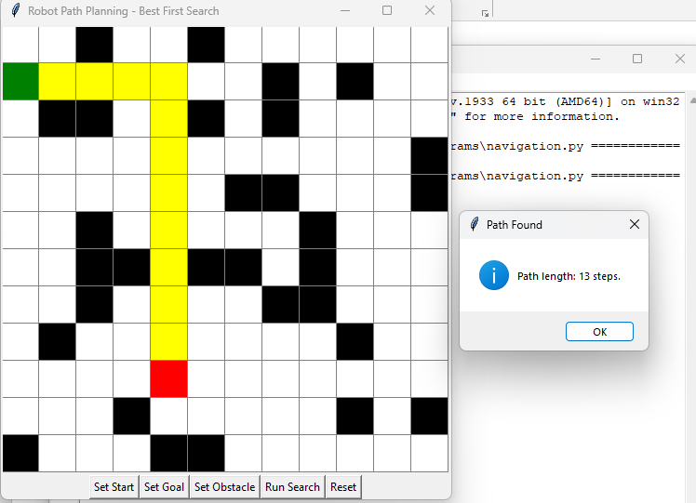

.
6)Conclusion:
The implementation of a robot navigation system using Best-First Search (BFS) demonstrates a practical and efficient approach to pathfinding in grid-based environments. By leveraging a heuristic function—specifically, the Manhattan Distance—the system effectively prioritizes exploration towards the goal, enabling faster and more intelligent decision-making compared to uninformed methods,this project successfully showcases how intelligent search strategies can be integrated into robot path planning systems to enable autonomous navigation in diverse and dynamic environments. Future enhancements can include dynamic obstacle handling, diagonal movement, cost-based heuristics, or integration with physical robotics frameworks for real-world deployment.

